59. Stop and Wait ARQ protocol

First, In the Stop and wait as the noiseless protocol, the sender sends a data and waits for acknowledgement by the receiver. If the ack is not received, the sender does not sends another data frame.

Thus, during transmission if either transfer of data packet or ACK fails, the sender or the receiver waits for an infinite time.

Hence Stop and Wait ARQ was created.

The function of the ARQ is as same as the normal ARQ, but it sends the same data packet to the receiver, if the ack is not received by the sender within a specific time or if receiver does not receive a data packet.

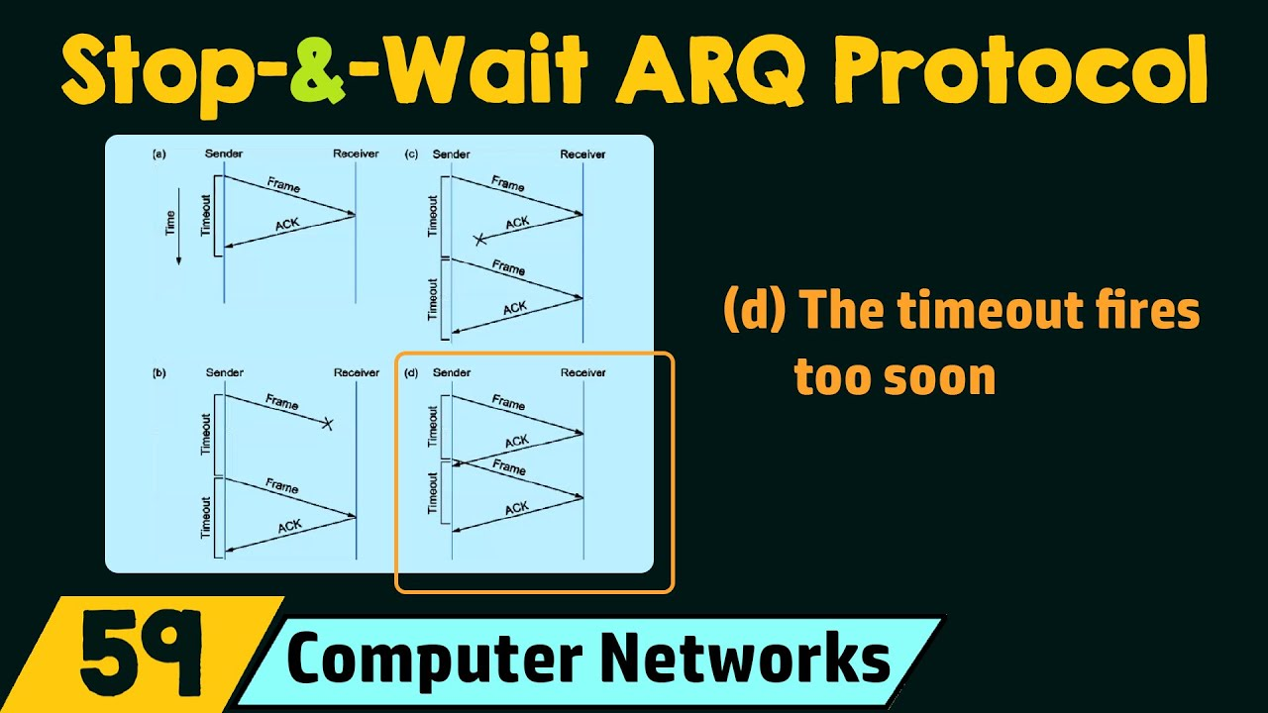

The main disadvantages of the Stop and Wait ARQ protocol are –

1. One frame at a time.
2. Poor utilization of bandwidth. (If bandwidth is 1000bps but sender sends 1 bps, what’s the use then.)
3. Poor Performance.